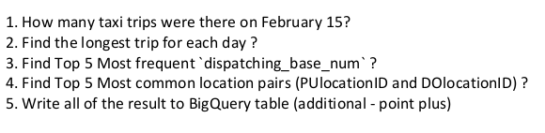

Repository: <https://github.com/HD-Project/SparkAssignment.git>

1. Screenshoot 1

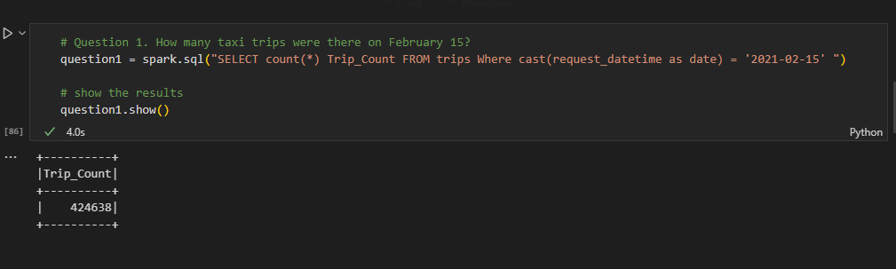

1. Screenshoot 2

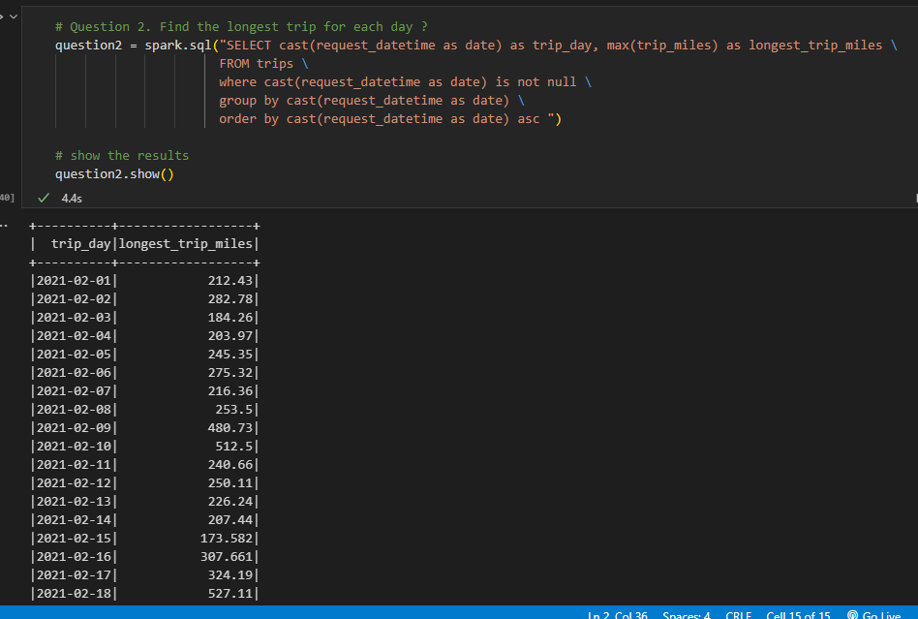

1. Screenshoot 3

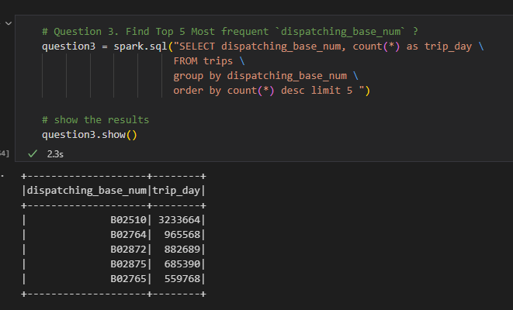

1. Screenshoot 4

